STAD BRUSSEL
departement STEDENBOUW – STADSVERNIEUWINGSCEL
Duurzaam Wijkcontract De MAROLLEn

Bijlage 1 : perimeter van het DWC De Marollen

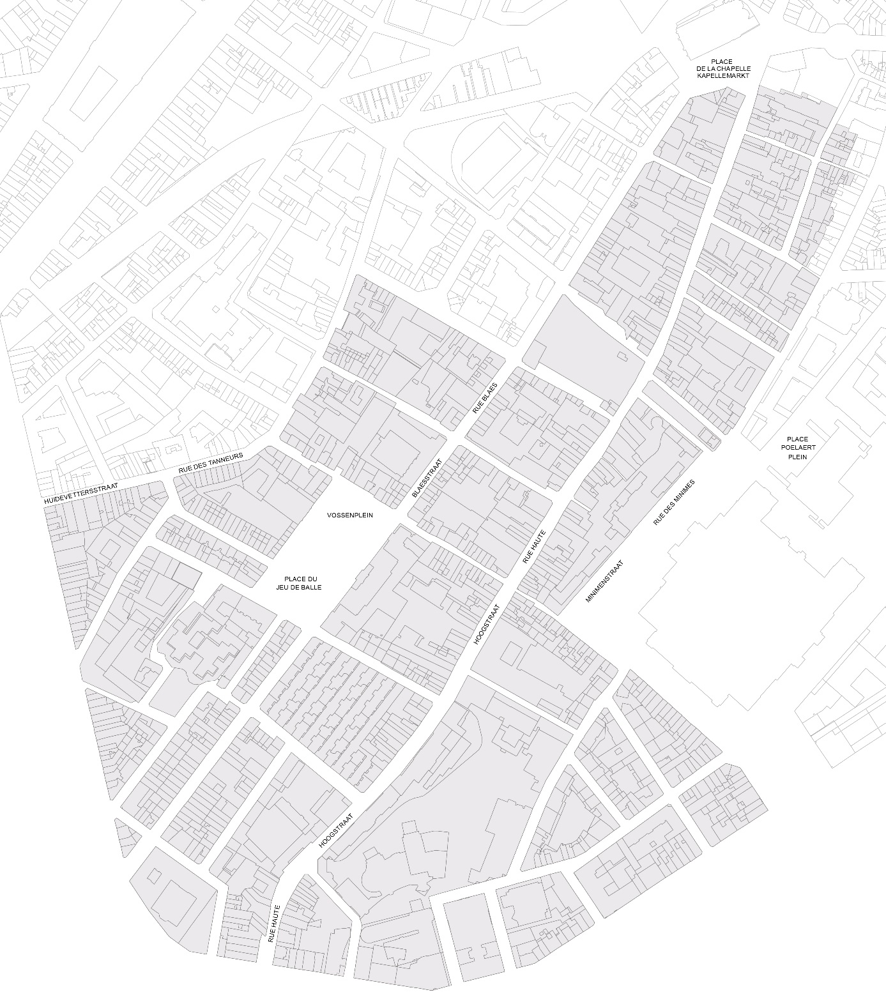

Bijlage 2 : kandidaturenformulier
Naam van het initiatief:
………………………………………………………………………………………………………………………………………………………………….
IDENTIFICATIE VAN DE VERANTWOORDELIJKE(N) VAN HET INITIATIEF:

Naam van de verantwoordelijke(n) :
………………………………………………………………………………………………………………………………………………………………………………………………
………………………………………………………………………………………………………………………………………………………………………………………………
………………………………………………………………………………………………………………………………………………………………………………………………
………………………………………………………………………………………………………………………………………………………………………………………………
(Desgevallend), Naam en voornaam van de hoofdverantwoordelijke : ………………………………………..…………………..…………………..
(Desgevallend), Naam en voornaam van de contactpersoon : ………………………………………………………………..…………………………….

Categorie :
Inwoner(s) Vzw Feitelijke vereniging Instelling/Organisatie
Andere:
- Adres : ……………………………………………………………………………………..……………………………………………………………………………
- E-mail : ……………………………………………………………………………………………………………………………………..…………………………..
- Tel./gsm : ………………………………………………………………………………………………………………………………..…………………………….

Bankrekeningnummer (IBAN) : ………………………………………………………………………………………..………….………..……………………………..
Houder van de rekening : ………………………………………………………………………………………………………………………..……………………………

Indien de verantwoordelijke van het initiatief niet in de perimeter van het DWC De Marollen gevestigd is, motivatie van zijn belangstelling voor de wijk :
………………………………………………………………………………………………………………………………………………………………………………………………
………………………………………………………………………………………………………………………………………………………………………………………………
………………………………………………………………………………………………………………………………………………………………………………………………
………………………………………………………………………………………………………………………………………………………………………………………………
………………………………………………………………………………………………………………………………………………………………………………………………
………………………………………………………………………………………………………………………………………………………………………………………………
………………………………………………………………………………………………………………………………………………………………………………………………
………………………………………………………………………………………………………………………………………………………………………………………………

Eventuele partners bij het project
Coördinaten | Betrokkenheid
…………………………………………………………………………………………………………..  ………………………………………………………………………………………………………….. | …………………………………………………………………………
…………………………………………………………………………………………………………..  ………………………………………………………………………………………………………….. | …………………………………………………………………………
…………………………………………………………………………………………………………..  ………………………………………………………………………………………………………….. | …………………………………………………………………………
…………………………………………………………………………………………………………..  ………………………………………………………………………………………………………….. | …………………………………………………………………………
…………………………………………………………………………………………………………..  ………………………………………………………………………………………………………….. | …………………………………………………………………………
…………………………………………………………………………………………………………..  ………………………………………………………………………………………………………….. | …………………………………………………………………………
…………………………………………………………………………………………………………..  ………………………………………………………………………………………………………….. | …………………………………………………………………………
…………………………………………………………………………………………………………..  ………………………………………………………………………………………………………….. | …………………………………………………………………………

Omschrijving van het initiatief
Algemene omschrijving en lokalisatie van het initiatief
……………………………………………………………………………………………………………………………………………………………………………………………………………………………………………………………………………………………………………………………………………………………………………………………………………………………………………………………………………………………………………………………………………………………………………………………………………………………………………………………………………………………………………………………………………………………………………………………………………………………………………………………………………………………………………………………………………………………………………………………………………………………………………………………………………………………………………………………………………………………………………………………………………………………………………………………………………………………………………………………………………………………………………………………………………………………………………………………………………………………………………………………………………………………………………………………………………………………………………………………………………………………………………………………………………………………………………………………………………………………………………………………………………………………………………………………………………………………………………………………………………………………………………………………………………………………………………………………………………………………………………………………………………………………………………………………………………………………………………………………………………………………………………………………………………………………………………………………………………………………………………………………………………………………………………………………………………………………………………………………………………………………………………………………………………………………………………………………………………………………………………………………………………………………………………………………………………………………………………………………………………………………………………………………………………………………………………………………………………………………………………………………………………………………………………………………………………………………………………………………………………………………………………………………………………………………………………………………………………………………………………………………………………………………………………………………………………………………………………………………………………………………………………………………………………………………………………………………………………………………………………………………………………………………………………………………………………………………………………………………………………………………………………………………………………………………………………………………………………………………………………………………………………………………………………………………………………………………………………………………………………………………………………………………………………………………………………………………………………………………………………………………………………………………………………………………………………………………………………………………………………………………………………………………………………………………………………………………………………………………………………………………………………………………………………………………………………………………………………………………………………………………………………………………………………………………………………………………………………………………………………………………… Lokalisatie van het initiatief
………………………………………………………………………………………………………………………………………………………………………………………………………………………………………………………………………………………………………………………………………………………………………………………………………………………………………………………………………………………………………………………………………………………………………………………………………………………………………………………………………………………………………………………………………………………………………………………………………………………………………………………………………………………………………………………………………………………………………………………………………………………………………………………………………………………………………………………………………………………………………………………………………………………………………………………………………………………………………………………………………………………………………………………………………………………………………………………………………………………………………………………………………………………………………………………………………………………………………………………………………………………………………………………………………………………………………………………………………………………………………………………………………………………………………………………………………………………………………………………………………………………………………………………………………………………………………………………………………………………………………………………………………………………………………………………………………………………………………………………………………………………………………………………………………………………………………………………………………………………………………………………………………………………………………………………………………………………………………………………………………………………………………………………………………………………………………………………………………………………………………………………………………………………………………………………………………………………………………………………………………………………………………………………………………………………………………………………………………………………………………………………………………………………………………………………………………………………………………………………………………………………………………………………………………………………………………………………………………………………………………………………………………………………………………………………………………………………………………………………………………………………………………………………………………………………………………………………………………………………………………………………………………………………………………………………………………………………………………………………………………………………………………………………………………………………………………………………………………………………………………………………………………………………………………………………………………………………………………………………………………………………………………………………………
Doelstellingen (overeenstemming met één of meerdere doelstellingen hernomen in artikel 1
………………………………………………………………………………………………………………………………………………………………………………………………………………………………………………………………………………………………………………………………………………………………………………………………………………………………………………………………………………………………………………………………………………………………………………………………………………………………………………………………………………………………………………………………………………………………………………………………………………………………………………………………………………………………………………………………………………………………………………………………………………………………………………………………………………………………………………………………………………………………………………………………………………………………………………………………………………………………………………………………………………………………………………………………………………………………………………………………………………………………………………………………………………………………………………………………………………………………………………………………………………………………………………………………………………………………………………………………………………………………………………………………………………………………………………………………………………………………………………………………………………………………………………………………………………………………………………………………………………………………………………………………………………………………………………………………………………………………………………………………………………………………………………………………………………………………………………………………………………………………………………………………………………………………………………………………………………………………………………………………………………………………………………………………………………………………………………………………………………………………………………………………………………………………………………………………………………………………………………………………………………………………………………………………………………………………………………………………………………………………………………………………………………………………………………………………………………………………………………………………………………………………………………………………………………………………………………………………………………………………………………………………………………………………………………………………………………………………………………………………………………………………………………………………………………………………………………………………………………………………………………………………………………………………………………………………………………………………………………………………………………………………………………………………………………………………………………………………………………………………………………………………………………………………………………………………………………………………………………………………………………………………………………………………………………………………………………………………………………………………………………………………………………………………………………………………………………………………………………………………………………………………………………………………………………………………………………………………………………………………………………………………………………………………………………………………………………………………………………………………………………………………………………………………………………………………………………………………………………………………………………………………………………………………………………………………………………………………………………………………………………………………………………………………
Verwachte resultaten van het initiatief
………………………………………………………………………………………………………………………………………………………………………………………………………………………………………………………………………………………………………………………………………………………………………………………………………………………………………………………………………………………………………………………………………………………………………………………………………………………………………………………………………………………………………………………………………………………………………………………………………………………………………………………………………………………………………………………………………………………………………………………………………………………………………………………………………………………………………………………………………………………………………………………………………………………………………………………………………………………………………………………………………………………………………………………………………………………………………………………………………………………………………………………………………………………………………………………………………………………………………………………………………………………………………………………………………………………………………………………………………………………………………………………………………………………………………………………………………………………………………………………………………………………………………………………………………………………………………………………………………………………………………………………………………………………………………………………………………………………………………………………………………………………………………………………………………………………………………………………………………………………………………………………………………………………………………………………………………………………………………………………………………………………………………………………………………………………………………………………………………………………………………………………………………………………………………………………………………………………………………………………………………………………………………………………………………………………………………………………………………………………………………………………………………………………………………………………………………………………………………………………………………………………………………………………………………………………………………………………………………………………………………………………………………………………………………………………………………………………………………………………………………………………………………………………………………………………………………………………………………………………………………………………………………………………………………………………………………………………………………………………………………………………………………………………………………………………………………………………………………………………………………………………………………………………………………………………………………………………………………………………………………………………………………………………………
Beoogd/betrokken publiek bij het initiatief en ter beschikking gestelde middelen om dit publiek te bereiken :
………………………………………………………………………………………………………………………………………………………………………………………………………………………………………………………………………………………………………………………………………………………………………………………………………………………………………………………………………………………………………………………………………………………………………………………………………………………………………………………………………………………………………………………………………………………………………………………………………………………………………………………………………………………………………………………………………………………………………………………………………………………………………………………………………………………………………………………………………………………………………………………………………………………………………………………………………………………………………………………………………………………………………………………………………………………………………………………………………………………………………………………………………………………………………………………………………………………………………………………………………………………………………………………………………………………………………………………………………………………………………………………………………………………………………………………………………………………………………………………………………………………………………………………………………………………………………………………………………………………………………………………………………………………………………………………………………………………………………………………………………………………………………………………………………………………………………………………………………………………………………………………………………………………………………………………………………………………………………………………………………………………………………………………………………………………………………………………………………………………………………………………………………………………………………………………………………………………………………………………………………………………………………………………………………………………………………………………………………………………………………………………………………………………………………………………………………………………………………………………………………………………………………………………………………………………………………………………………………………………………………………………………………………………………………………………………………………………………………………………………………………………………………………………………………………………………………………………………………………………………………………………………………………………………………………………………………………………………………………………………………………………………………………………………………………………………………………………………………………………………………………………………………………………………………………………………………………………………………………………………………………………………………………………………………………………………………………………………………………………………………………………………………………………………………………………………………………………………………………………………………………………………………………………………………………………………………………………………………………………………………………………………………………………………………………………………………………………………………………………………………………………………………………………………………………………………………………………………………………………………………………………………………………………………………………………………………………………………………………………………………………………………………………………………
Omschrijving van de toepasselijkheid en van de impact van het initiatief op de perimeter van het DWC De Marollen
………………………………………………………………………………………………………………………………………………………………………………………………………………………………………………………………………………………………………………………………………………………………………………………………………………………………………………………………………………………………………………………………………………………………………………………………………………………………………………………………………………………………………………………………………………………………………………………………………………………………………………………………………………………………………………………………………………………………………………………………………………………………………………………………………………………………………………………………………………………………………………………………………………………………………………………………………………………………………………………………………………………………………………………………………………………………………………………………………………………………………………………………………………………………………………………………………………………………………………………………………………………………………………………………………………………………………………………………………………………………………………………………………………………………………………………………………………………………………………………………………………………………………………………………………………………………………………………………………………………………………………………………………………………………………………………………………………………………………………………………………………………………………………………………………………………………………………………………………………………………………………………………………………………………………………………………………………………………………………………………………………………………………………………………………………………………………………………………………………………………………………………………………………………………………………………………………………………………………………………………………………………………………………………………………………………………………………………………………………………………………………………………
………………………………………………………………………………………………………………………………………………………………………………………………………………………………………………………………………………………………………………………………………………………………………………………………………………………………………………………………………………………………………………………………………………………………………………………………………………………………………………………………………………………………………………………………………………………………………………………………………………………………………………………………………………………………………………………………………………………………………………………………

Planning van het initiatief
STAPPEN | UITVOERINGEN | VOORZIENE DATUMS | PLAATS
………………………………………….  …………………………………………. | ………………………………………….  …………………………………………. | ………………………………………….  …………………………………………. | ………………………………………….  ………………………………………….
………………………………………….  …………………………………………. | ………………………………………….  …………………………………………. | ………………………………………….  …………………………………………. | ………………………………………….  ………………………………………….
………………………………………….  …………………………………………. | ………………………………………….  …………………………………………. | ………………………………………….  …………………………………………. | ………………………………………….  ………………………………………….
………………………………………….  …………………………………………. | ………………………………………….  …………………………………………. | ………………………………………….  …………………………………………. | ………………………………………….  ………………………………………….
………………………………………….  …………………………………………. | ………………………………………….  …………………………………………. | ………………………………………….  …………………………………………. | ………………………………………….  ………………………………………….
………………………………………….  …………………………………………. | ………………………………………….  …………………………………………. | ………………………………………….  …………………………………………. | ………………………………………….  ………………………………………….
………………………………………….  …………………………………………. | ………………………………………….  …………………………………………. | ………………………………………….  …………………………………………. | ………………………………………….  ………………………………………….

Budget van het initiatief
Door onderhavig formulier te ondertekenen, verklaart de initiatiefverantwoordelijke op eer dat zijn begroting eerlijk en realistisch werd opgesteld.
Hij erkent eveneens dat elke financiële bijdrage toegekend door de autoriteiten dient besteed te worden in het kader van de doelstellingen waarvoor deze werden toegekend.
Type uitgave | Bedrag
Ex : location de tonnelles | 300€
TOTAL

(de tabel van onderhavig document herneemt uitsluitend bedragen die dienen als voorbeeld)

Ondertekening en verbintenis van de initiatiefverantwoordelijke(n)
Bij deze verklaart/verklaren de initiatiefverantwoordelijke/initiatiefverantwoordelijken kennis genomen te hebben van het reglement van de initiatievenoproep 2019 en verbindt/verbinden zich ingeval van selectie deze volledig te respecteren. Het reglement maakt integraal deel uit van kandidaturenformulier. Elke pagina dient eveneens ondertekend te worden door de initiatiefverantwoordelijke(n).

Opgemaakt te ......................................................... op .........................................................

Naam,  ......................................................... | Voornaam,  ......................................................... | Handtekening,  .........................................................

